Used coffee filter in the botton of pot

[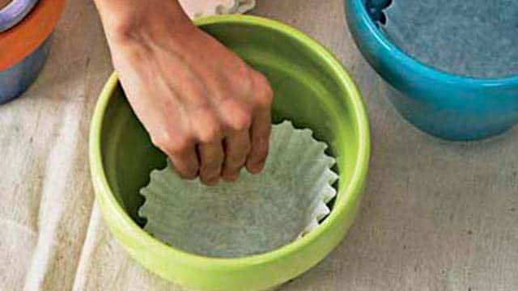](https://balconygardenweb-lhnfx0beomqvnhspx.netdna-ssl.com/wp-content/uploads/2016/06/coffee-filter-in-pot.jpg)

Next time you’re repotting a plant, keep the soil where it belongs with the help of a coffee filter. Simply lining the pot keeps the drainage holes in the bottom free from clogging up — and soil from sneaking out after watering.